Class Assignment 1 (Chapter 2) 02/04/2021

Name: Max Shi

Name: Erika McCarthy

Name: Sydney Wind

Name:

Questions (20 pts):

Q1. What are the values of quantum numbers l and n for a 5d electron

l – 2
n = 5

Q2. (a) Two excited states for d⁴ configuration are shown. Which is likely to have lower energy? Explain your choice in terms of Coulombic and exchange energies.
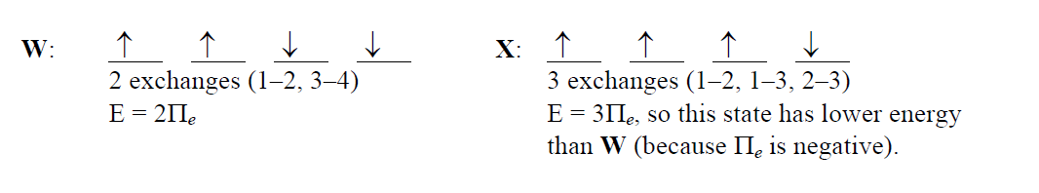

X has lower energy because it has a group of three electrons with the same spin that can be exchanged to be arranged in six different ways. W has two groups of two, that can be arranged in only four ways.

(b)
Y: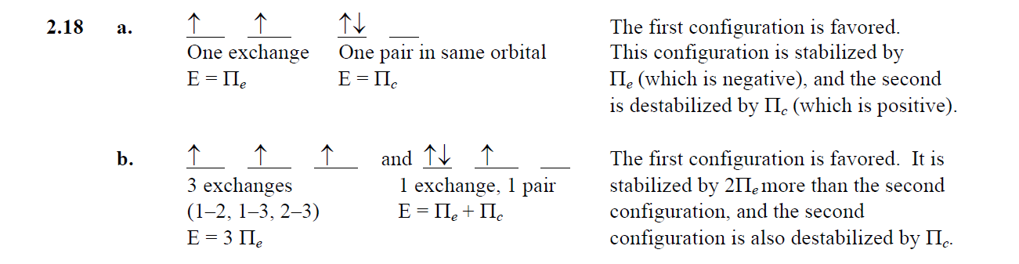

Z:

Y has lower energy because the three electrons are in different orbitals in the same spin, while Z has only two electrons with the same spin, also with repulsion in the first orbital. Therefore, Y has lower energy.

Q3. Provide explanations for the following phenomena:
- The electronic configuration of Cr is[Ar]4s¹3d⁵ rather than [Ar]4s²3d⁴

The first configuration would result in six unpaired electrons with the same spin, which has exchange energy possible in the 3d orbital between 5 electrons. The second configuration has repulsion in the s orbital, and less electrons to exhibit exchange energy in the 3d orbital, resulting in higher energy and a less stable configuration.

- The electronic configuration of Ti is[Ar]4s²3d², but that of Cr²⁺ is [Ar]3d⁴
Although these both have the same amount of electrons, Cr2+ had two electrons removed from its original configuration of 4s²3d⁴. The two electrons were removed out of the 4s orbital because those electrons are the least shielded in the atom, as they are in the highest orbital, and are removed first.

Q4. Using Slater’s rules, determine Z* for
- 3 p electron in P, S, Cl, and Ar. Is the calculated value of Z* consistent with the relative size of these atoms?

Z* = Z – S

P (1s2 2s2 2p6 3s2 3p3):
S = 4 * 0.35 + 8 * 0.85 + 2 = 10.2
Z* = 15 – 10.2 = 4.8

S (1s2 2s2 2p6 3s2 3p4):
S = 5 * 0.35 + 8 * 0.85 + 2 = 10.55
Z* = 16 – 10.55 = 5.45

Cl (1s2 2s2 2p6 3s2 3p5):
S = 6 * 0.35 + 8 * 0.85 + 2 = 10.9
Z* = 17 – 10.9 = 6.1

Ar (1s2 2s2 2p6 3s2 3p6):
S = 7 * 0.35 + 8 * 0.85 + 2 = 11.25
Z* = 18 – 11.25 = 6.75

The trend between the two are inversely proportional: as the effective nuclear charge increases, the size of the atom decreases.

- a 4s and a 3d electron of Cu. Which type of electron is more likely to be lost when copper forms a positive ion?

Cu (1s2 2s2 2p6 3s2 3p6 3d10 4s1)

4s:
S = 10 + 18 * 0.85 = 25.3
Z* = 29 – 25.3 = 3.7

3d:
S = 18 + 9 * 0.35 = 21.2
Z* = 29 – 21.2 = 7.8

Because 4s has a lower effective nuclear charge, that electron will more likely be lost on formation of a cation.

Q5. In each of the following pairs, pick the element with the higher ionization energy and explain your choice.
- Fe, Ru

Iron because it is in a lower period than ruthenium in the same group, therefore its electrons are closer to its nucleus, and harder to remove.

- P, S

Phosphorus has lower because the electron removed from sulfur is the first electron to be paired within the orbital, therefore it is easier to remove this first electron from sulfur.

- K, Br

Bromine because it has much higher effective nuclear charge than potassium, and it is in the same period, therefore it is harder to remove an electron.

- C, N

Nitrogen because it has higher effective nuclear charge and is in the same period as carbon, making the electron harder to remove.

- Cd, In

Cadmium because the first ionized electron of indium is in a higher level by itself, which means it is easier to remove.

- Cl, F

Flourine because its electrons are closer to the nucleus and is in the same group as chlorine, which makes its first electron take more energy to remove.

Q6. On the basis of electronic configurations, explain why
- Sulfur has a lower electronic affinity than chlorine
  - Chlorine accepting an electron would complete its 3p orbital, making it very stable.
- Iodine has lower affinity than bromine
  - The size of iodine is large enough that adding an electron will not release as much energy as adding an electron to bromine, therefore it has lower affinity.
- Boron has a lower ionization energy than beryllium
  - The first ionized electron from boron would be the first electron in its 2p orbital, which is easier to remove than an electron from a paired 2s orbital.

Q7. Predict the largest and smallest radius in each series, and account for your choices.

- Se²⁻, Br⁻, Rb⁺, Sr²⁺

These all have the same amount of electrons, so the greatest positive charge would have the smallest radius, and the least positive charge would have the largest. Therefore, Sr²⁺ is the smallest and Se²⁻ is the largest.

- Co⁴⁺, Co³⁺, Co²⁺, Co

These all have the same number of protons, but different number of electrons, so the species with the least electrons would be smallest, and the most electrons would be largest. Therefore, Co⁴⁺ is the smallest and Co is the largest.

